Now Playing, 2001
Description | I got a job to work for the government as an IT Assistant! On my first day, they asked me to reinstall the Windows XP operating system... weird we still use that in 2026. I reinstalled it and wanted to test the functionality so I booted up the Original Media Player. I was so shocked when the male singer's voice started playing as the default song. His voice was so crisp and clear.. I must know what microphone he used to record it. What microphone model did the original album's producer say he used for those vocals?  Submit RCC{model}. - I don't need the brand, it's probably a Sony.
Files | No downloadable files or container. Publish the player brief. Solving this challenge unlocks The Missing Power Box.  Submission format: RCC{model}.
Hint(s) | 1. The vocal sample came from a commercial album, not a Windows sound-design session.  2. The song is David Byrne's Like Humans Do. Follow the recording of Look Into the Eyeball.  3. Michael Mangini discussed the album in Avalon's AT2 interview in February 2002. The microphone and preamplifier are different devices.
Walkthrough | 1. Search for the original Windows XP sample music. Microsoft's announcement identifies David Byrne's Like Humans Do, from Look Into the Eyeball. The other familiar XP sample, Highway Blues, is instrumental.  2. Search for David Byrne Look Into the Eyeball recording interview. The February 2002 Avalon interview names Michael Mangini as the album's producer and engineer. Its first page connects him to the album.    3. On PDF page 3, read the left column beneath the vocal-processing discussion. Mangini names the Sony C800 and says it was used on every song. The Vt-737sp is the preamplifier, not the microphone.  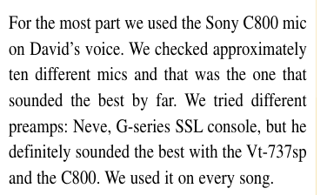  4. Submit the designation printed in the interview: RCC{c800}. The question asks what Mangini named; it does not establish a physical C800 versus C800G revision. The complete saved interview contains the surrounding discussion.
Flag | RCC{c800}

